**Computer Networks Lab Report**

**Assignment-** 8

**Class:** BCSE-III

**Semester:** 1st

**Group:**  A3

**Group Members:-**

* PARTHIV SARKAR - 002110501134
* ARKAJYOTI NASKAR - 002110501144
* SOHAM CHOWDHURY - 002110501145
* ARIYAN BHAUMIK - 002110501149

**Problem Statement:**

**Implement any two protocols using TCP/UDP Socket as suitable.**

**1. FTP**

**2. DNS**

**3. Telnet**

# DNS Protocol

**Overview :** On the internet for communication between client and server , client requires server/host’s IP address, but in this crowded network it’s not possible to remember Ip of every host to connect to it. So there comes the domain name [example.com] . It’s much easier to remember domain names rather than IP addresses. But the client in the lower lever requires an IP address to communicate. Here the DNS come.

Clients can request DNS to send the domain’s IP address, so that client can use the IP to connect.

## How it works :

DNS protocol works over UDP protocol.

* Client send and dns request consists of domain name, type of query [A, NS, CNAME, MX, TXT etc.], query class type [usually it is IN (internet)].
* The DNS server will check for the domain in the zone records .
* If DNS has zone records of that domain, will send the Answers of the query.
* If there is no zone record for that domain, it will send the dns request to top level TLD root servers and from there the request will be send to the latest nameservers of that domain . The nameserver will forward the result to that client.

## Implementation :

DNS protocol and its packet encoding and decoding have been implemented as per specified in RFC 1035.

*DNS request has this structure*

+ +

| Header |

+ +

| Question | the question for the name server

+ +

| Answer | RRs answering the question

+ +

| Authority | RRs pointing toward an authority

+ +

| Additional | RRs holding additional information

+ +

For a basic DNS server, the implementation of the Header, Question and Answer section is mandatory.

*Header section consists of*

* 16 byte of transaction ID (to track the requests between client , dns server and multiple root servers)
* A one bit field that specifies whether this message is a query (0), or a response (1).
* OPCODE : A four bit field that specifies a kind of query in this message.
  + 0 - Standard Query
  + 1 - an inverse query
  + 2 - a server status request
* AA : Authoritative Answer - this bit is valid in responses, and specifies that the responding name server is an authority for the domain name in question section.
* TC : TrunCation - specifies that this message was truncated due to length greater than that permitted on the transmission channel.
* QDCOUNT : an unsigned 16 bit integer specifying the number of entries in the question section.
* ANCOUNT : an unsigned 16 bit integer specifying the number of resource records in the answer section.
* NSCOUNT : an unsigned 16 bit integer specifying the number of name server resource records in the authority records section.
* ARCOUNT : an unsigned 16 bit integer specifying the number of resource records in the additional records section.
* Other parameters also there Recursion Available [RA], Response Code [RCODE]

*Question section format*

0 1 2 3 4 5 6 7 8 9 0 1 2 3 4 5

+--+--+--+--+--+--+--+--+--+--+--+--+--+--+--+--+

| |

/ QNAME /

/ /

+--+--+--+--+--+--+--+--+--+--+--+--+--+--+--+--+

| QTYPE |

+--+--+--+--+--+--+--+--+--+--+--+--+--+--+--+--+

| QCLASS |

+--+--+--+--+--+--+--+--+--+--+--+--+--+--+--+--+

It’s consists of :

* QNAME : Domain name of query [ex. Google.com]. It’s variable length
* QTYPE : An numeric value which represents Record Type. [A, CNAME, MX, TXT, AAAA]
* QCLASS : A two octet code that specifies the class of the query. For example, the QCLASS field is IN for the Internet.

*Answer Section Format :*

0 1 2 3 4 5 6 7 8 9 0 1 2 3 4 5

+--+--+--+--+--+--+--+--+--+--+--+--+--+--+--+--+

|  |  |  |
| --- | --- | --- |
| | |  | | |
| / |  | / |
| / | NAME | / |
| | |  | | |

+--+--+--+--+--+--+--+--+--+--+--+--+--+--+--+--+

| TYPE |

+--+--+--+--+--+--+--+--+--+--+--+--+--+--+--+--+

| CLASS |

+--+--+--+--+--+--+--+--+--+--+--+--+--+--+--+--+

| TTL |

+--+--+--+--+--+--+--+--+--+--+--+--+--+--+--+--+

| RDLENGTH |

+--+--+--+--+--+--+--+--+--+--+--+--+--+--+--+--|

/ RDATA /

/ /

+--+--+--+--+--+--+--+--+--+--+--+--+--+--+--+--+

It consists of :

* NAME : a domain name to which this resource record pertains.
* TYPE : Type of record [A, NS, CNAME, MX, TXT etc.]
* CLASS : A two octet code that specifies the class of the query. For example, the QCLASS field is IN for the Internet
* TTL : a 32 bit unsigned integer that specifies the time interval (in seconds) that the resource record may be cached before it should be discarded
* RDLENGTH : an unsigned 16 bit integer that specifies the length in octets of the RDATA field.
* RDATA : a variable length string of octets that describes the resource.

## Folder Structure :

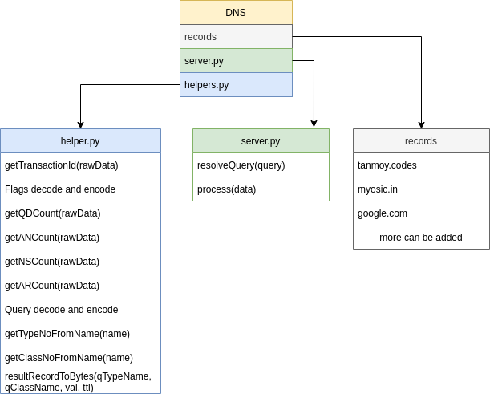

**Code Implementation -**

*server.py*

import socket

from helpers import * import os

UDP_IP_ADDRESS = "127.0.0.1"

UDP_PORT_NO = 53

serverSock = socket.socket(socket.AF_INET, socket.SOCK_DGRAM) serverSock.bind((UDP_IP_ADDRESS, UDP_PORT_NO)

def resolveQuery(query:Query):

record_path = os.path.join(os.path.dirname( file ), "records", query.baseDomainName())

# If the file exists, then we have a record for this domain if os.path.exists(record_path):

answers = [] nameservers = []

# Read the file and parse the answers with open(record_path, "r") as f:

for curLine in f:

curLine = curLine.strip() # Strip to remove newlines

curLineParts = curLine.split("\t")

if len(curLineParts) < 3: continue

if curLineParts[0] == query.domainName(endDot=True) and curLineParts[1]

== query.queryClass():

if curLineParts[2] == query.queryType(): answers.append(curLine)

if curLineParts[2] == "NS": nameservers.append(curLine)

return (True, answers, nameservers)

# else , we have no record for this domain return (False, [], [])

def process(data):

transactionID = getTransactionID(data) flags = Flags.fromBytes(data, debug=False) QDCount = getQDCount(data) # Usually 1 ANCount = getANCount(data)

NSCount = getNSCount(data) # ARCount = getARCount(data)

ARCount = 0

query = Query.fromBytes(data) print("Transaction ID: " + transactionID)

# Find the record for this query result = resolveQuery(query)

if result[0]:

transactionID = data[:2]

QDCount = (QDCount).to_bytes(2, "big") ANCount = len(result[1]).to_bytes(2, "big") NSCount = len(result[2]).to_bytes(2, "big") ARCount = (0).to_bytes(2, "big")

else:

transactionID = data[:2]

QDCount = (QDCount).to_bytes(2, "big") ANCount = (0).to_bytes(2, "big")

NSCount = (0).to_bytes(2, "big") ARCount = (0).to_bytes(2, "big")

# Build the response # Header

responseHeader = transactionID + flags.toBytes() + QDCount + ANCount + NSCount +

ARCount

print("Response Header: " + str(responseHeader))

# Question

responseQuestion = query.toBytes()

print("Response Question: " + str(responseQuestion))

# Body responseBody = b""

for record in result[1]: record_split = record.split("\t") # Name | Class | Type | Val | TTL

responseBody += resultRecordToBytes(record_split[2], record_split[1], record_split[3], int(record_split[4]))

return responseHeader + responseQuestion + responseBody while True:

data, addr = serverSock.recvfrom(512)

serverSock.sendto(process(data), addr)

*helpers.py*

### Required datas

queryTypesName = ["A", "NS", "MD", "MF", "CNAME", "SOA", "MB", "MG", "MR", "NULL", "WKS", "PTR", "HINFO", "MINFO", "MX", "TXT"]

queryClassesName = ["IN", "CS", "CH", "HS"]

### Functions

# Get Transaction ID from data

def getTransactionID(rawData:bytes): transactionIDRaw = rawData[:2] transactionID = ""

for x in transactionIDRaw: transactionID += hex(x)[2:]

return transactionID

# Get flags from data class Flags:

def init (self, QR, OPCODE, AA, TC, RD, RA, Z, RCODE):

self.QR = QR self.OPCODE = OPCODE

self.AA = AA self.TC = TC

self.RD = RD self.RA = RA self.Z = Z self.RCODE = RCODE

def str (self):

return str(self.QR) + " " + str(self.OPCODE) + " " + str(self.AA) + " " + str(self.TC) + " " + str(self.RD) + " " + str(self.RA) + " " + str(self.Z) + " " + str(self.RCODE)

@staticmethod

def fromBytes(rawData:bytes, debug=False): # first byte |second byte

# | 1 | 4 | 1 | 1 | 1 | 1 | 3| 4 | # | QR|Opcode| AA| TC| RD| RA| Z|RCODE|

first_byte = ord(rawData[2:3]) second_byte = ord(rawData[3:4])

if debug:

print("[DEBUG] First byte: " + str(first_byte)+" "+bin(first_byte)) print("[DEBUG] Second byte: " + str(second_byte)+" "+bin(second_byte))

QR = first_byte >> 7

OPCODE = (first_byte & 0b01111000 ) >> 3 AA = (first_byte & 0b00000100) >> 2

TC = (first_byte & 0b00000010) >> 1 RD = (first_byte & 0b00000001)

RA = second_byte >> 7

Z = (second_byte & 0b1110000) >> 4 RCODE = second_byte & 0b1111

if debug:

print("[DEBUG] QR: " + str(QR)) print("[DEBUG] OPCODE: " + str(OPCODE)) print("[DEBUG] AA: " + str(AA))

print("[DEBUG] TC: " + str(TC))

print("[DEBUG] RD: " + str(RD))

print("[DEBUG] RA: " + str(RA))

print("[DEBUG] Z: " + str(Z)) print("[DEBUG] RCODE: " + str(RCODE))

return Flags(QR, OPCODE, AA, TC, RD, RA, Z, RCODE)

def toBytes(self):

first_byte = (self.QR << 7) + (self.OPCODE << 3) + (self.AA << 2) + (self.TC << 1)

+ self.RD

second_byte = (self.RA << 7) + (self.Z << 4) + self.RCODE

return first_byte.to_bytes(1, "big") + second_byte.to_bytes(1, "big")

# Get QD count from data

def getQDCount(rawData:bytes):

QDCountRaw = rawData[4:6] QDCount = ""

for x in QDCountRaw: QDCount += hex(x)[2:]

return int(QDCount)

# Get AN count from data

def getANCount(rawData:bytes): ANCountRaw = rawData[6:8] ANCount = ""

for x in ANCountRaw: ANCount += hex(x)[2:]

return int(ANCount)

# Get NS count from data

def getNSCount(rawData:bytes): NSCountRaw = rawData[8:10] NSCount = ""

for x in NSCountRaw: NSCount += hex(x)[2:]

return int(NSCount)

# Get AR count from data

def getARCount(rawData:bytes): ARCountRaw = rawData[10:12] ARCount = ""

for x in ARCountRaw: ARCount += hex(x)[2:]

return int(ARCount)

# Query Questions parser class Query:

def init (self, nameParts, type, qclass): self.nameParts = nameParts

self.type = type self.qclass = qclass

def baseDomainName(self):

return self.nameParts[-2] + "." + self.nameParts[-1]

def domainName(self, endDot=False): res = '.'.join(self.nameParts) if endDot and res[-1] != ".":

res += "." return res

def queryType(self): if self.type > 16:

return "Unknown"

return queryTypesName[self.type - 1]

def queryClass(self): if self.qclass > 4:

return "Unknown"

return queryClassesName[self.qclass - 1]

def str (self):

return self.domainName() + " " + str(self.type) + " " + str(self.qclass)

@staticmethod

def fromBytes(rawData:bytes, debug=False): data = rawData[12:]

if debug:

print("[DEBUG] Data: ") print(data)

# Format : {length of characters + [string]} untill 0x00

domainParts = [] totalLengthOfDomainPartsWithLengthCharacter = 0

length = -1 tmp = ""

for byte in data: totalLengthOfDomainPartsWithLengthCharacter += 1 if byte == 0: # End of parts

if tmp != "":

domainParts.append(tmp) break

if length == -1: # Yet not started, so first byte is length length = byte

elif length == 0: # Read one part, so next byte is length domainParts.append(tmp)

tmp = "" length = byte

else: # Its part of domain name tmp += chr(byte)

length -= 1

tmp = data[totalLengthOfDomainPartsWithLengthCharacter:totalLengthOfDomainPartsWithLengthCharact er+4]

# QType

QTypeRaw = tmp[:2] QType = ""

for x in QTypeRaw: QType += hex(x)[2:]

QType = int(QType, 16) # QClass

QClassRaw = tmp[2:] QClass = ""

for x in QClassRaw: QClass += hex(x)[2:]

QClass = int(QClass, 16) if debug:

print("Domain Parts: " + str(domainParts))

print("QType: " + str(QType))

print("QClass: " + str(QClass))

return Query(domainParts, QType, QClass) def toBytes(self):

res = b""

for part in self.nameParts:

res += bytes([len(part)]) + bytes(part, "utf-8") res += b"\x00"

res += self.type.to_bytes(2, "big") res += self.qclass.to_bytes(2, "big") return res

# Get type no from Query type name def getTypeNoFromName(name):

for i in range(len(queryTypesName)): if name == queryTypesName[i]:

return i + 1

return 0

# Get class no from Query class name def getClassNoFromName(name):

for i in range(len(queryClassesName)): if name == queryClassesName[i]:

return i + 1

return 0

# Result Record to bytes

def resultRecordToBytes(qTypeName, qClassName, val:str, ttl:int):

print("Converting " + qTypeName + " " + qClassName + " " + val + " " + str(ttl)) res = b"\xc0\x0c"

res += getTypeNoFromName(qTypeName).to_bytes(2, "big") res += getClassNoFromName(qClassName).to_bytes(2, "big") res += ttl.to_bytes(4, "big")

if qTypeName == "A":

res += b"\x00\x04"

res += bytes(map(int, val.split("."))) elif qTypeName == "AAAA":

val = [int(x) for x in val.split(":")] res += len(val).to_bytes(2, "big")

for x in val:

res += x.to_bytes(2, "big")

else:

totalLen = 0 data = b""

for x in val.split("\n"): r = bytes(x, "utf-8") rLen = len(r) totalLen += rLen+1

data += rLen.to_bytes(1, "big") + r res += totalLen.to_bytes(2, "big")

res += data return res

## Working Demo [via dig] :

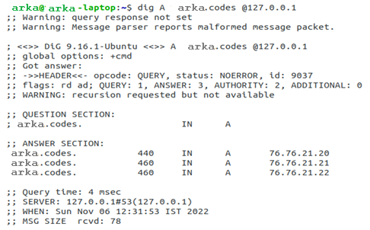

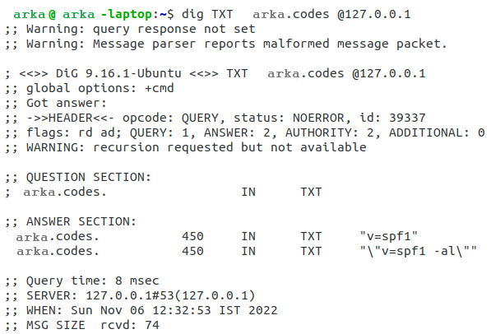

**Conclusion :** The implementation of the DNS server is working fine with the DNS client. However it can only send results based on the zone records available to it, So we can extend that by giving support for querying the root server.

# Telnet Protocol

**Overview -**Telnet is a network protocol used to virtually access a computer and to provide a two-way, collaborative and text-based communication channel between two machines. It follows a user command Transmission Control Protocol/Internet Protocol (TCP/IP) networking protocol for creating remote sessions

## Code Implementation -

import socket import subprocess

from threading import Thread from time import sleep

class TelentServer:

def init (self, host="127.0.0.1", port=5000): self.host = host

self.port = port self.exited = False self.exitedListening = False

self.sock = socket.socket(socket.AF_INET, socket.SOCK_STREAM) self.sock.bind((self.host, self.port)) self.sock.settimeout(2)

self.sock.listen() self.threads_pool = []

print("Server is listening on port", port)

def startProcess(self): while True:

try:

conn, addr = self.sock.accept() conn.settimeout(2) print("Connected by", addr)

t = Thread(target=self.handleClient, args=(conn, addr)) t.start()

self.threads_pool.append(t) except socket.timeout:

if self.exited: break

else :

continue

except:

break self.exitedListening = True

def handleClient(self, conn:socket.socket, addr): while True:

try:

data = conn.recv(1024)

res = subprocess.run(data.decode().strip(), shell=True, capture_output=True)

if res.returncode == 0: conn.sendall(res.stdout)

else:

conn.sendall(res.stderr)

if not data:

break

if data.decode().strip() == "exit": break

except socket.timeout: if self.exited:

break continue

except:

break conn.close()

def stopProcess(self): self.exited = True

while not self.exitedListening: sleep(1)

for t in self.threads_pool: try:

t.join() except:

pass self.sock.close()

if name == " main ": server = TelentServer()

try:

server.startProcess() except KeyboardInterrupt:

server.exited = True server.stopProcess() print("Server is closed")

## Working Demo [via Telnet Client] :

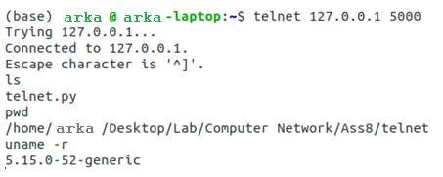

**Conclusion :** Telnet is a very important protocol to operate remote systems. We have built the Telnet Server on top of the TCP/IP stack and it’s compatible with any telnet client.